Mrs. Morgan’s  Student  News |  | 

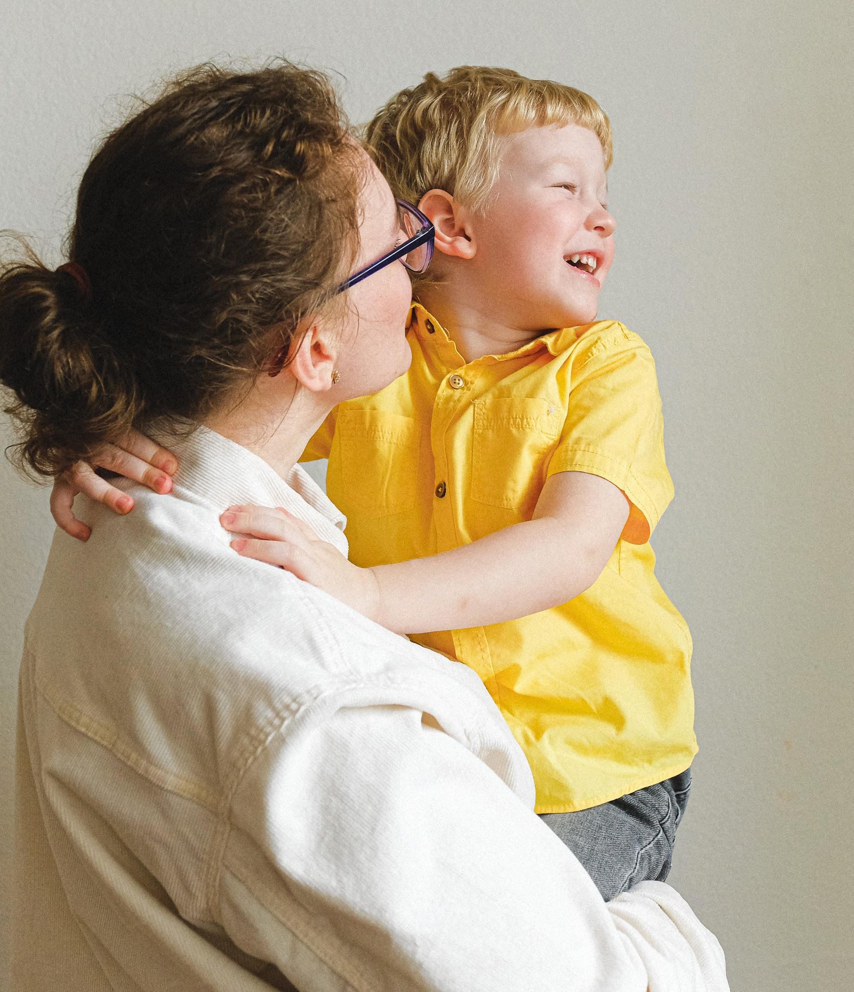 | News for the week of: August 24, 2026  HOMEWORK:  Reading: 20 minutes per night  Spelling Words: condense, source, whirling, rapidly, experience, ancient, predict, registered, rotating, rage.
WI
 | Content Standards for the Week:  READING: Hurricanes: Earth’s Mightiest Storms  (SKILLS): Text Features (Titles/Subtitles)  MATH: multiples
 | Other Communication:  Graded work will come home on Fridays (or whatever day is at the end of the week). Please check for any papers that say “fix” on them. Your child can fix them for a better grade.  August:  (28) No School  September  (4) First Friday  (7) No School  (14) Fall Pictures  (17) Chocolate Sales end  (18) No School  ***Nonfiction Text Features due September 14th***  PLEASE HAVE YOUR CHILD BRING A WATER BOTTLE EVERY DAY ALL YEAR!!

